**Azure Functions**

Write an ARM Template to deploy the azure function along with the code and other required configurations.

Azure Functions is the serverless computing service hosted on the Microsoft Azure public cloud. Azure Functions, and serverless computing, in general, is designed to accelerate and simplify application development.

Below screenshots will show how to create the function app and creating the timer to show time for every minute is over.

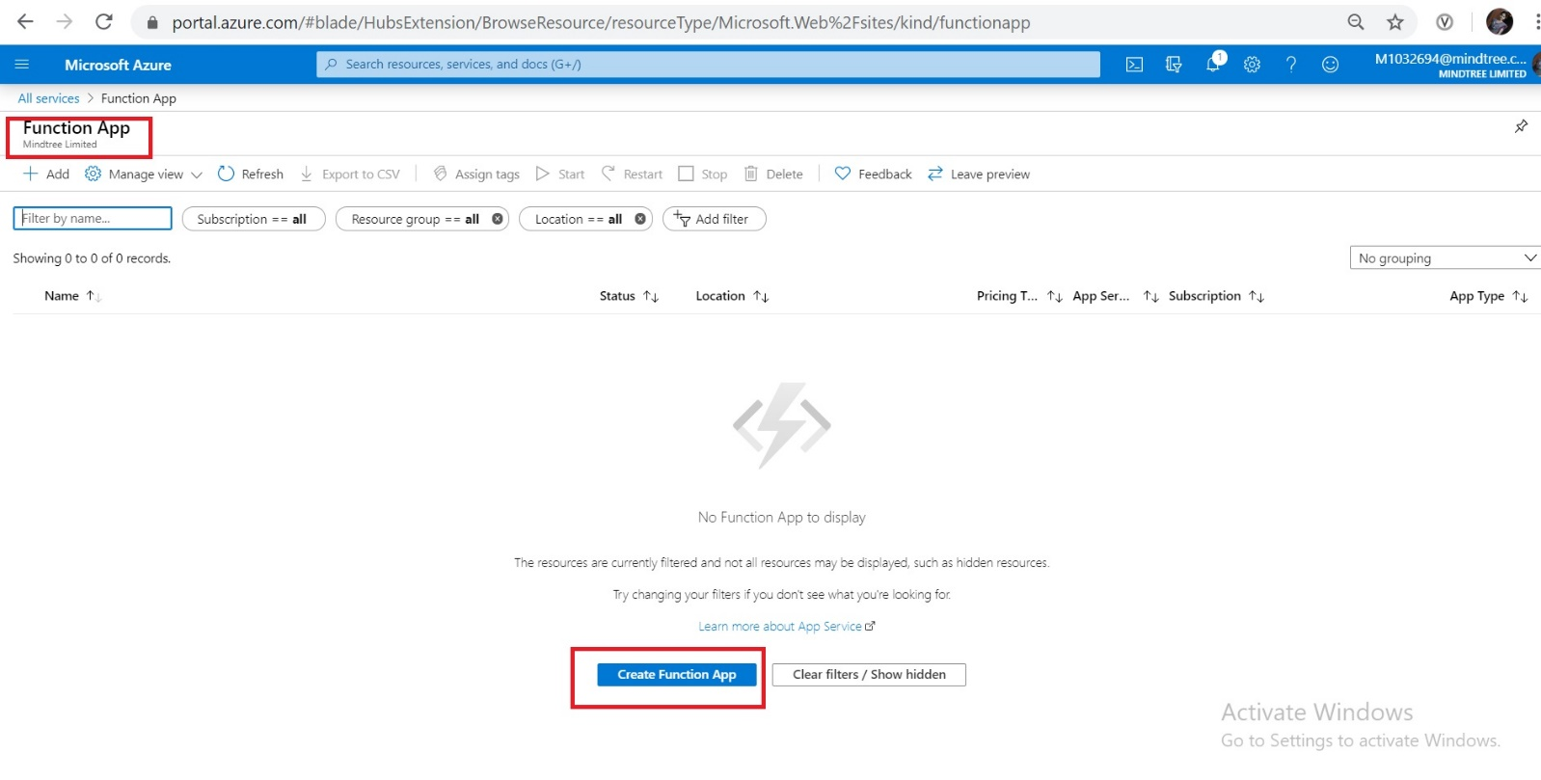

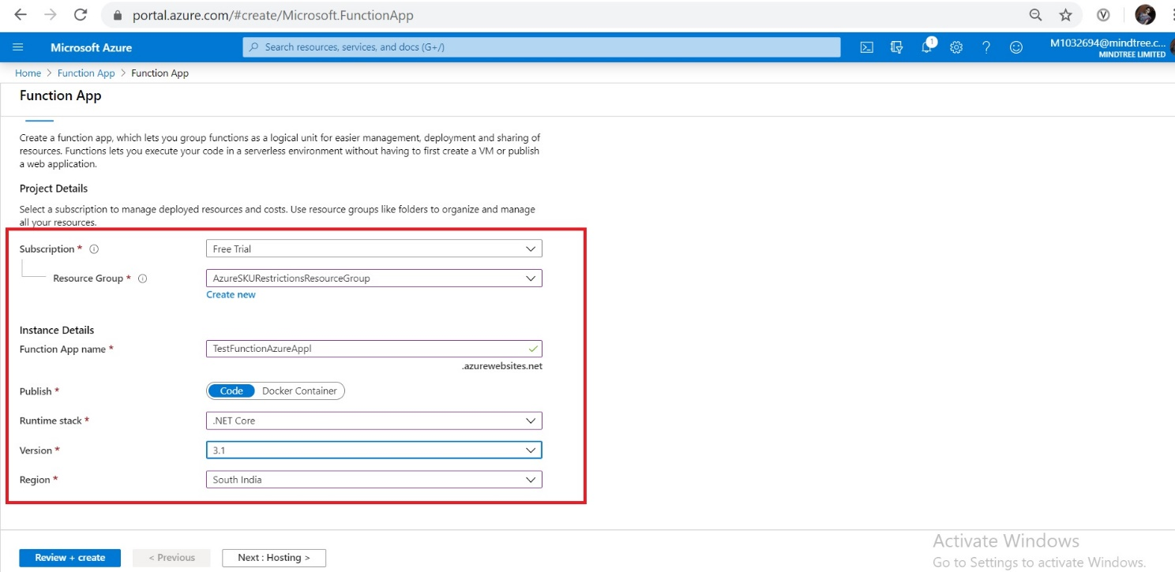

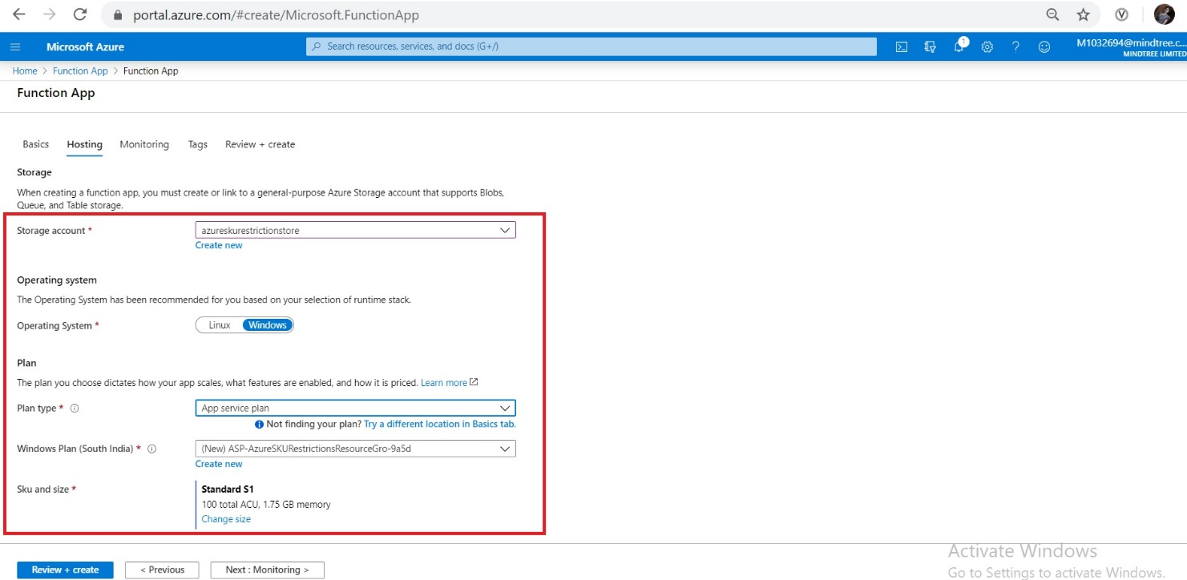

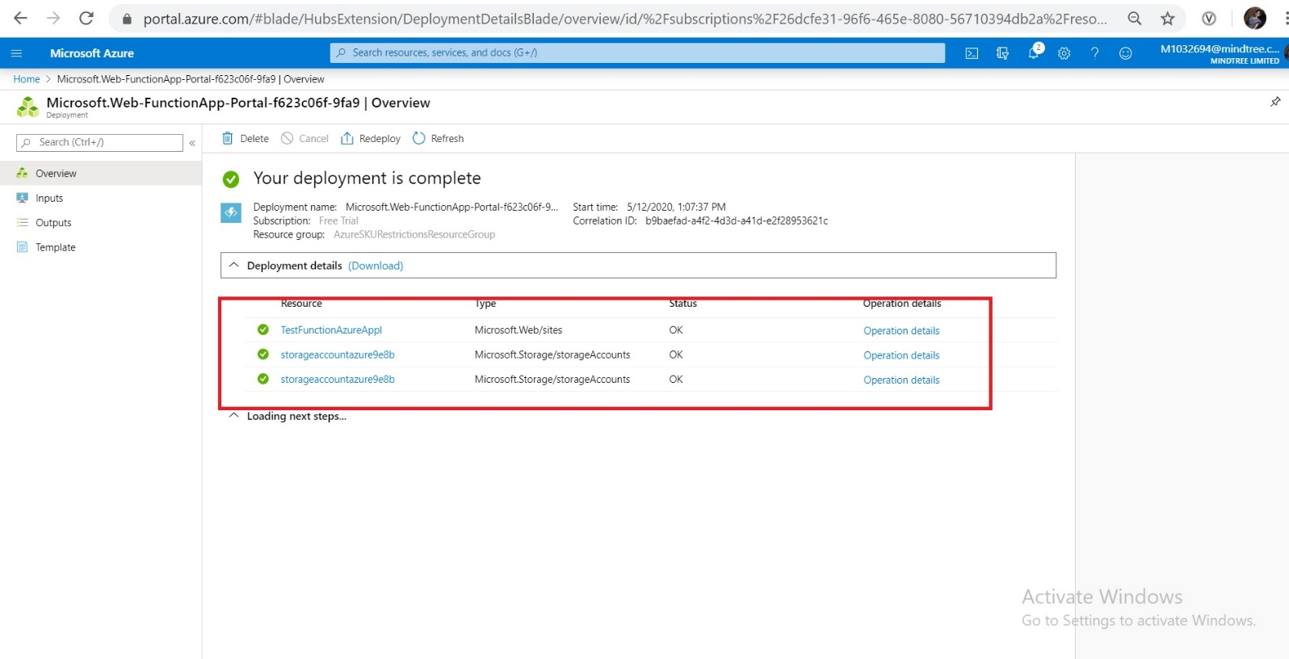

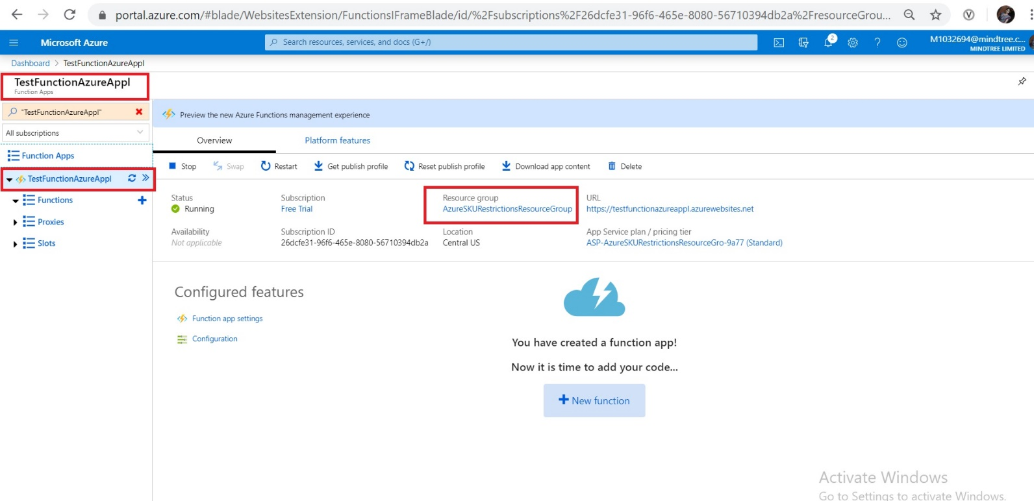

Creating new timer function

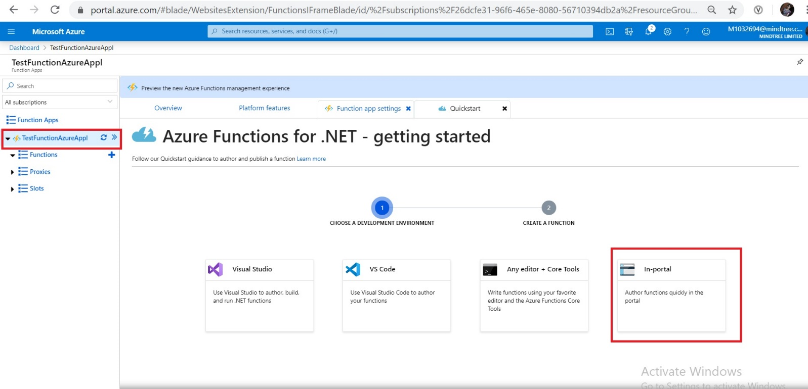

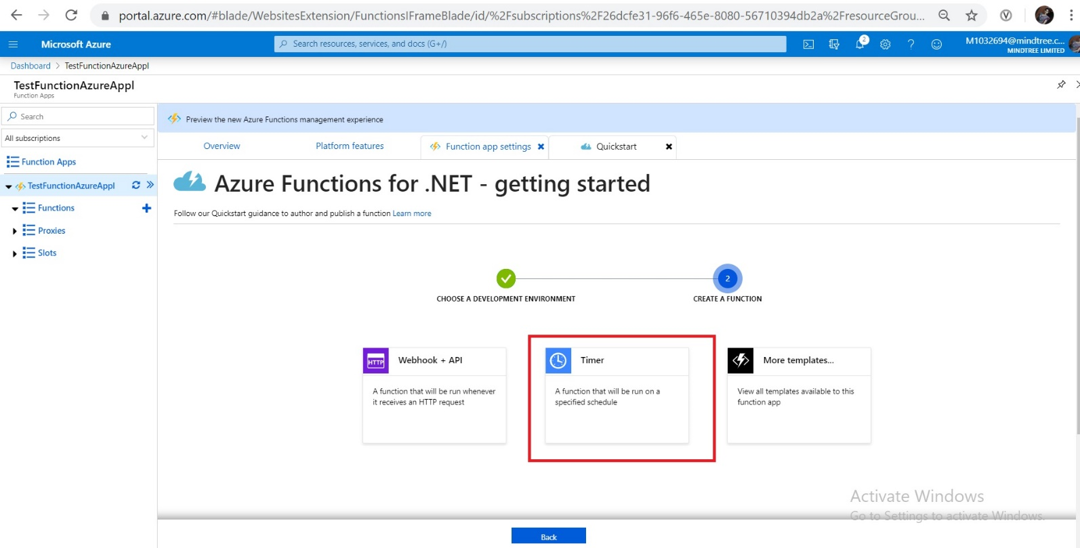

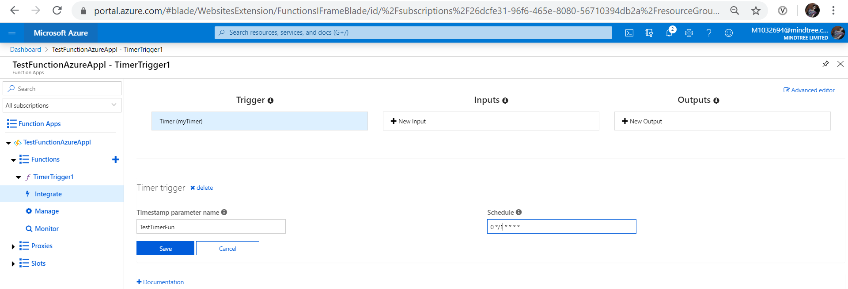

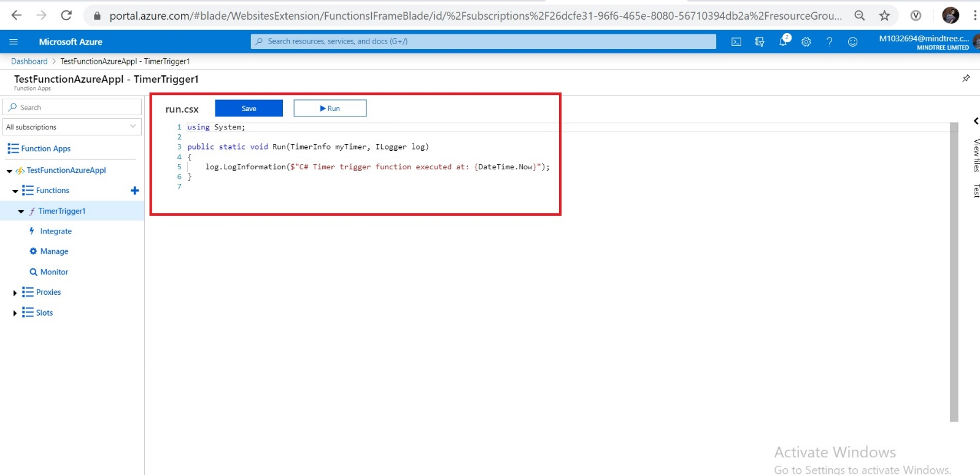

Once the above function created and when I click on the run button, it will give the out as time for every one minute. Below screenshot show the same.

